Steps to run the Application:

1. Copy the public ipv4 address from the EC2 instance created.

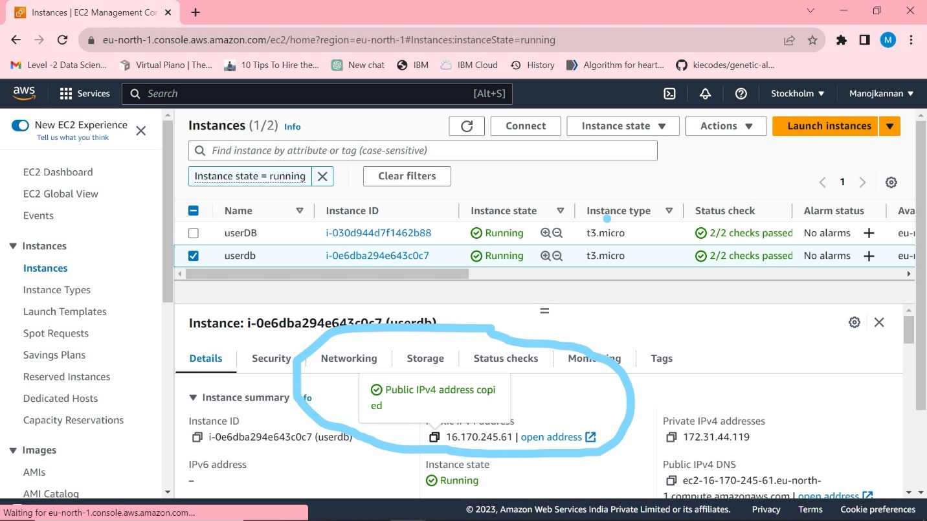

Fig 1.1

1. Run the PUTTY app

Copy the IP address in Host name, enter username as ec2-user, locate the ppf file in our local.

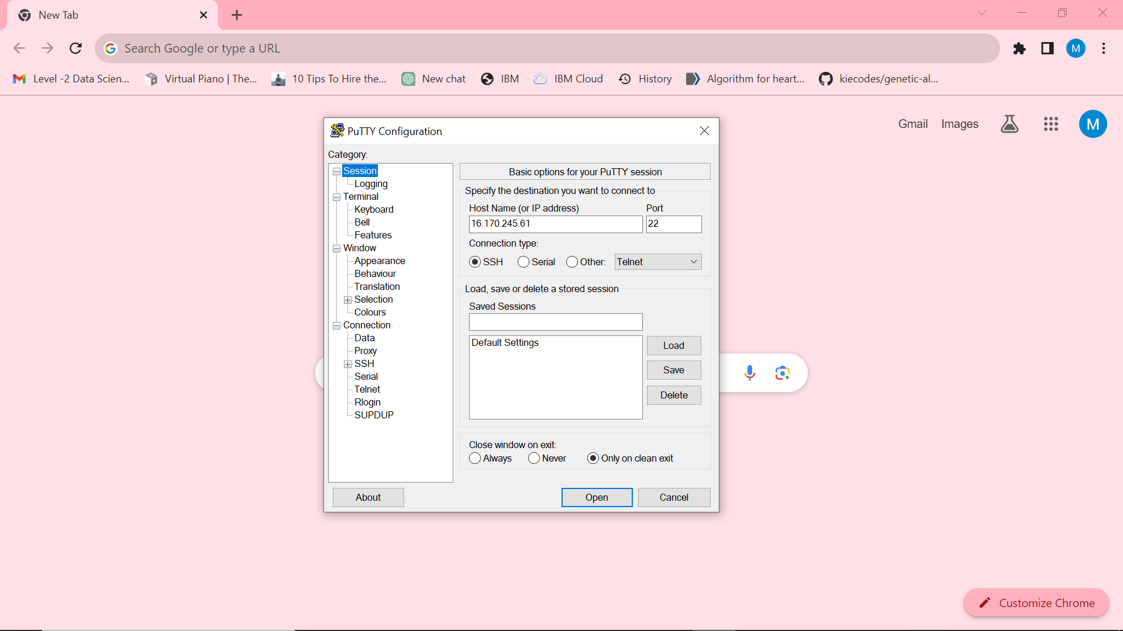

Fig 1.2

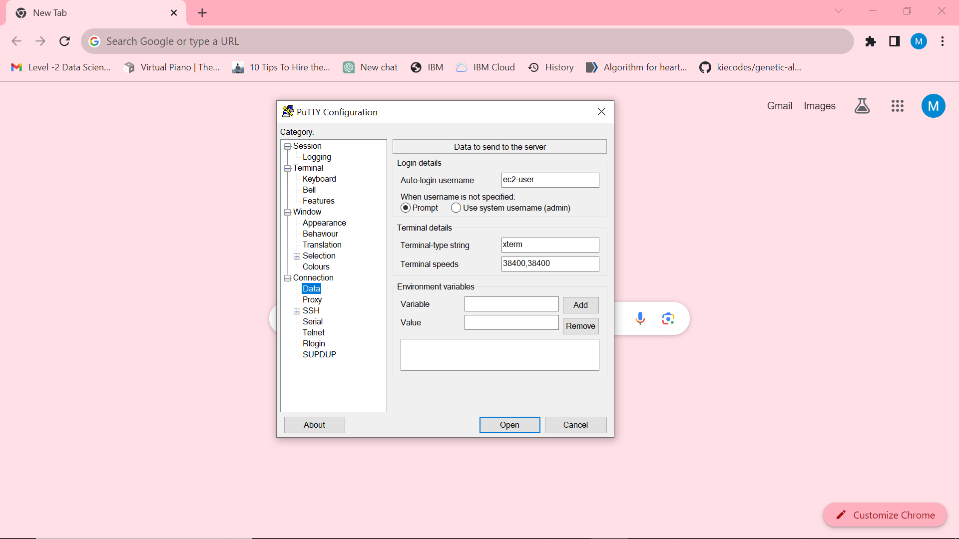

Fig 1.3

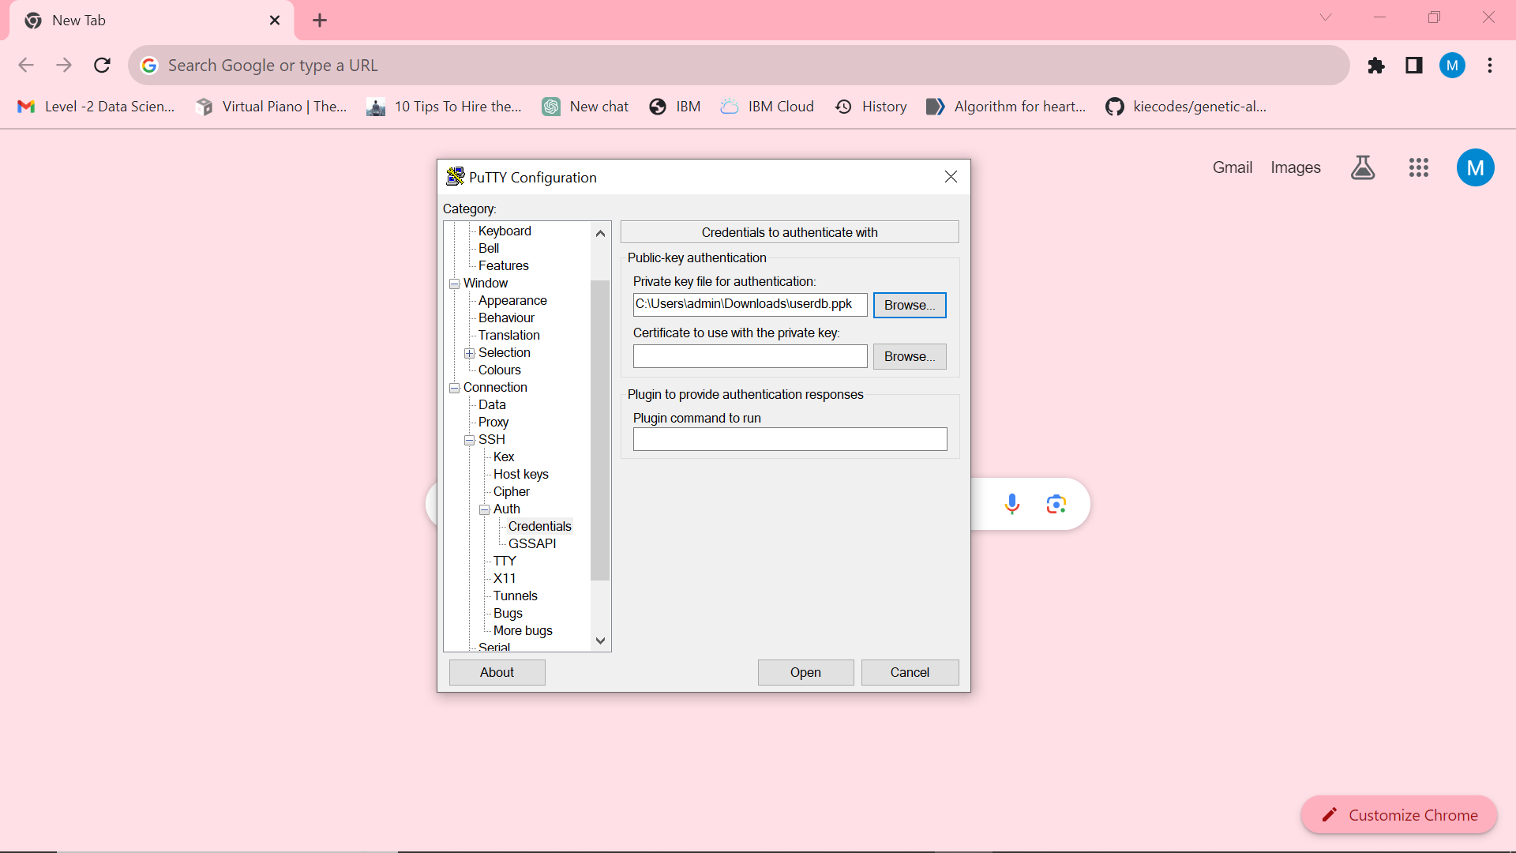

Fig 1.4

1. Generate jar file and run Spring boot application

Navigate to S3 bucket myapplication,

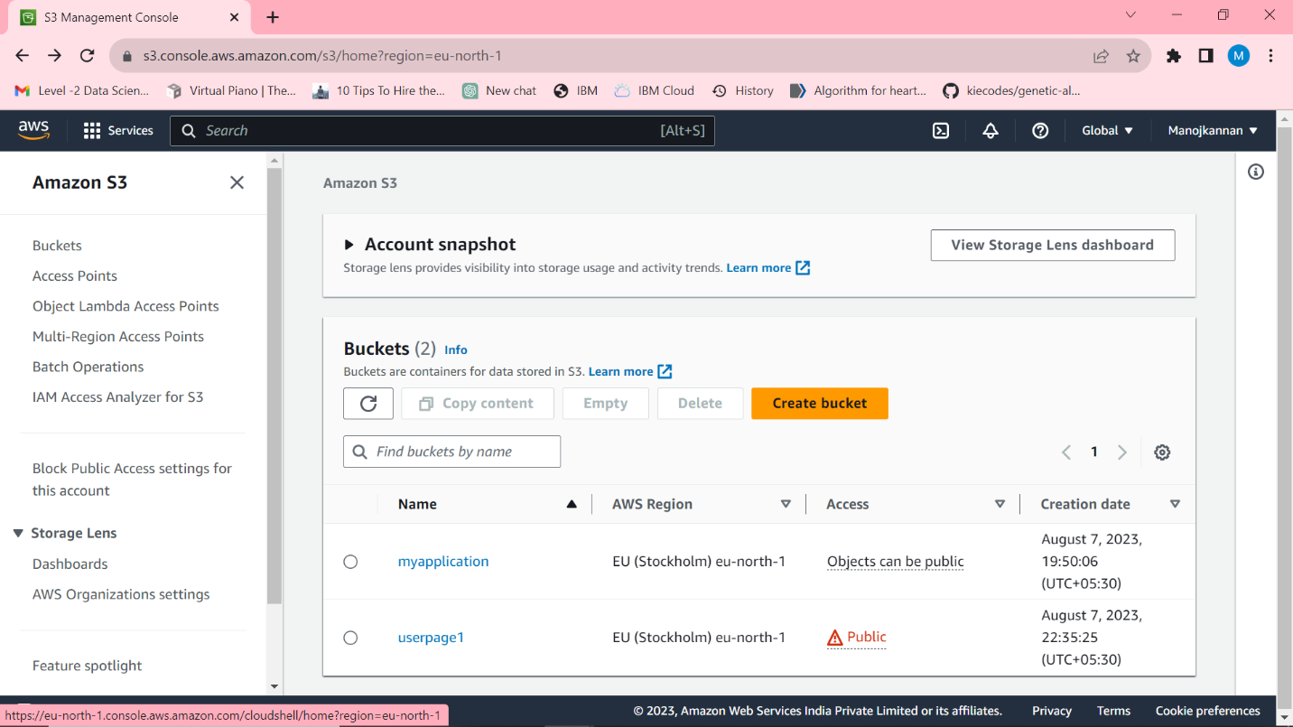

Fig 1.5

Click the jar file,

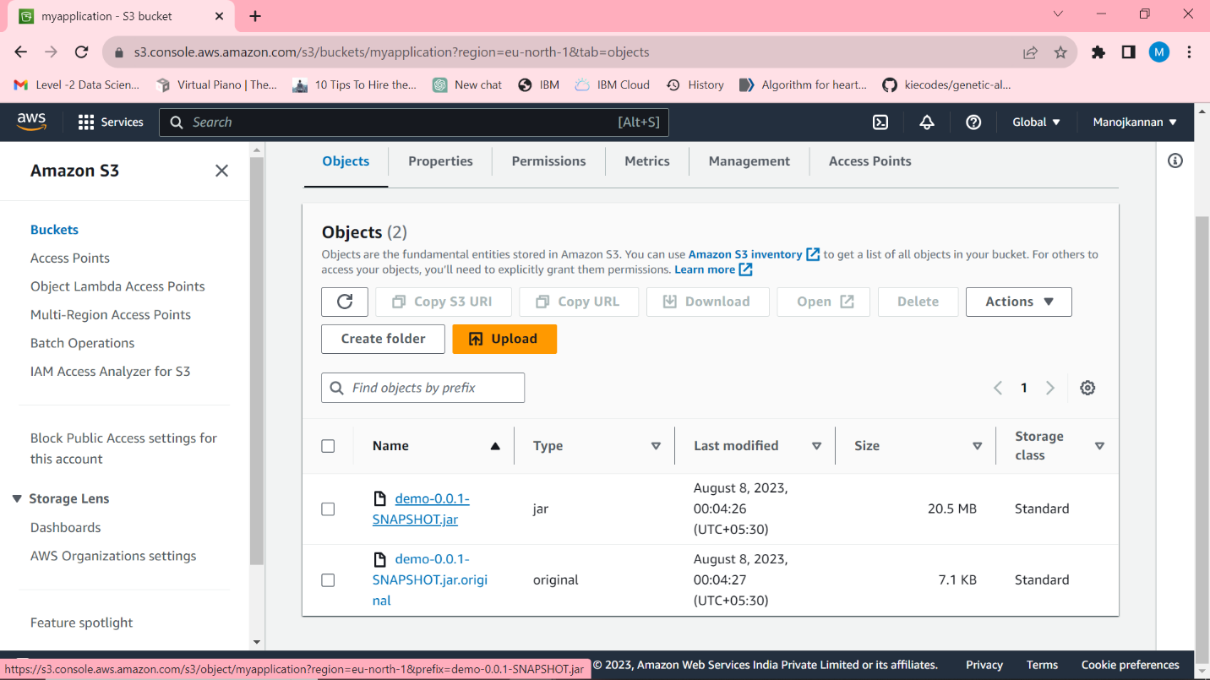

Fig 1.6

Copy the jar file url,

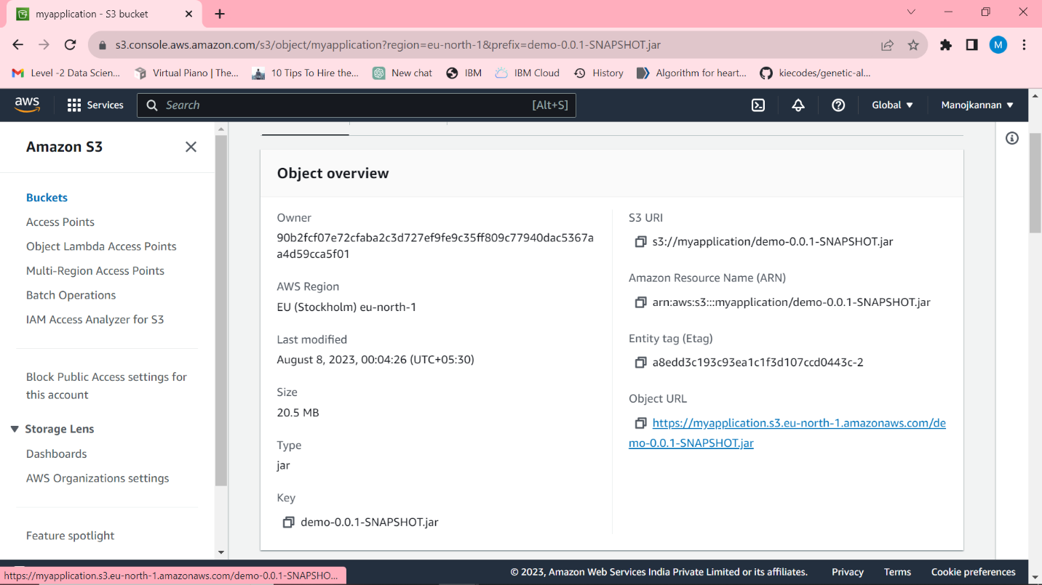

Fig 1.7

Execute the command “wget <jar file url>” in terminal, executable jar file will be generated in the terminal.

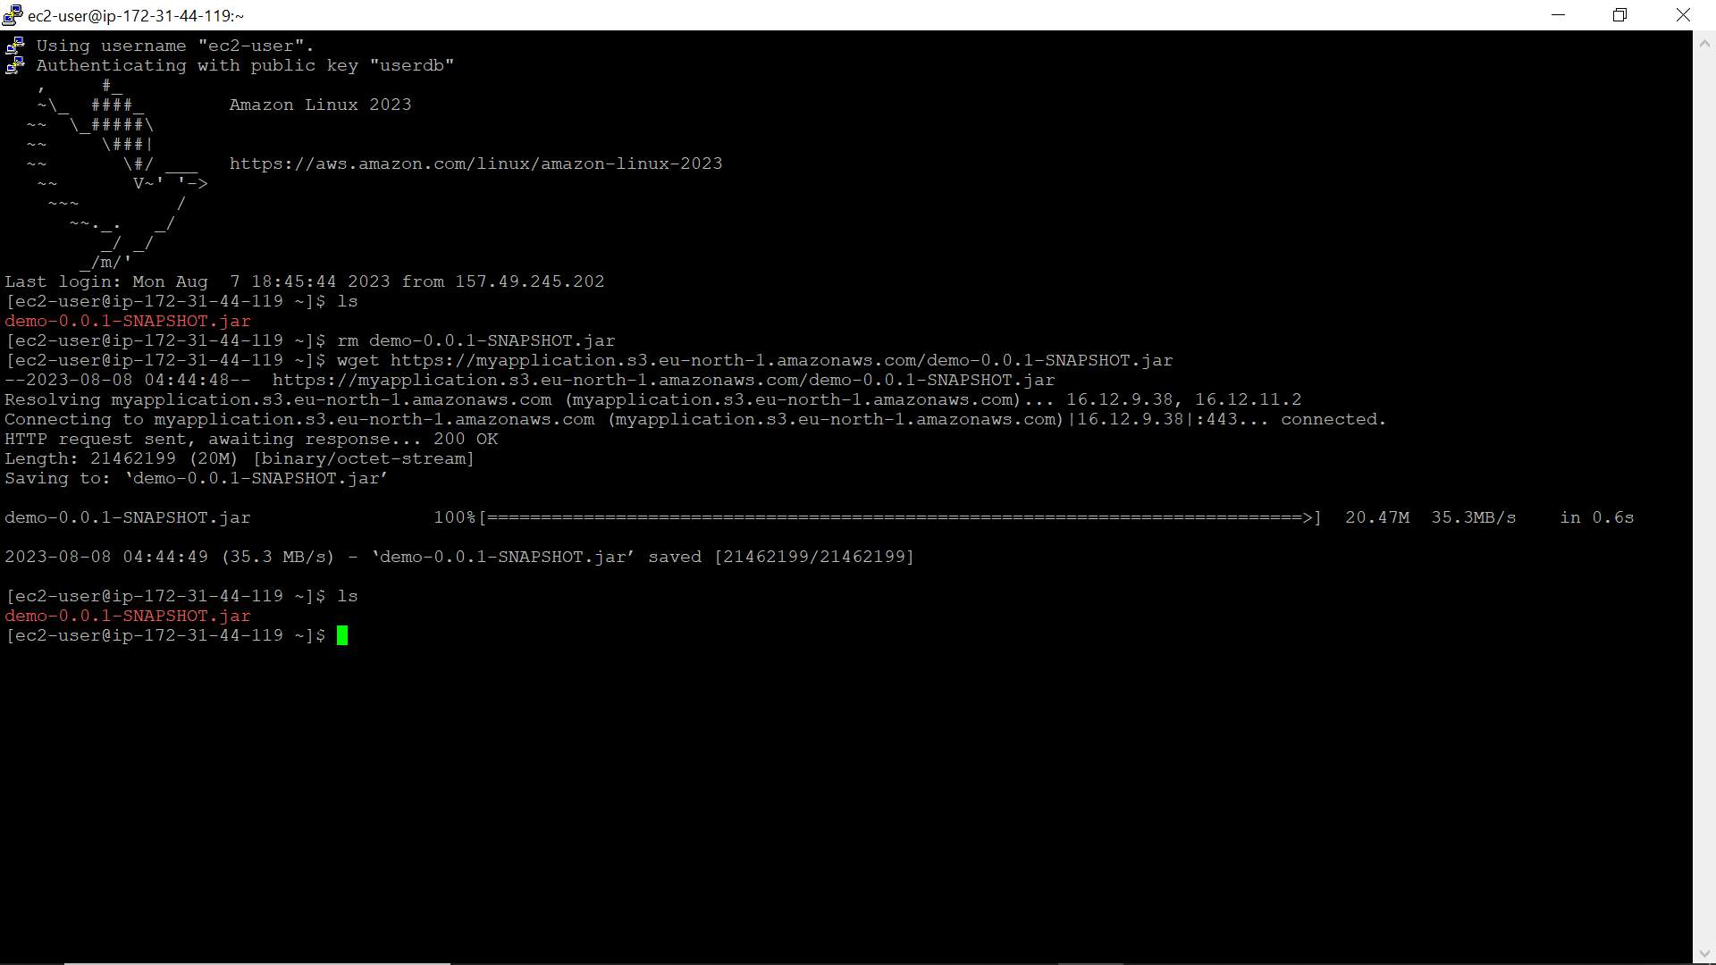

Fig 1.8

Now execute the spring boot application using command “java -jar <executable jar file>”

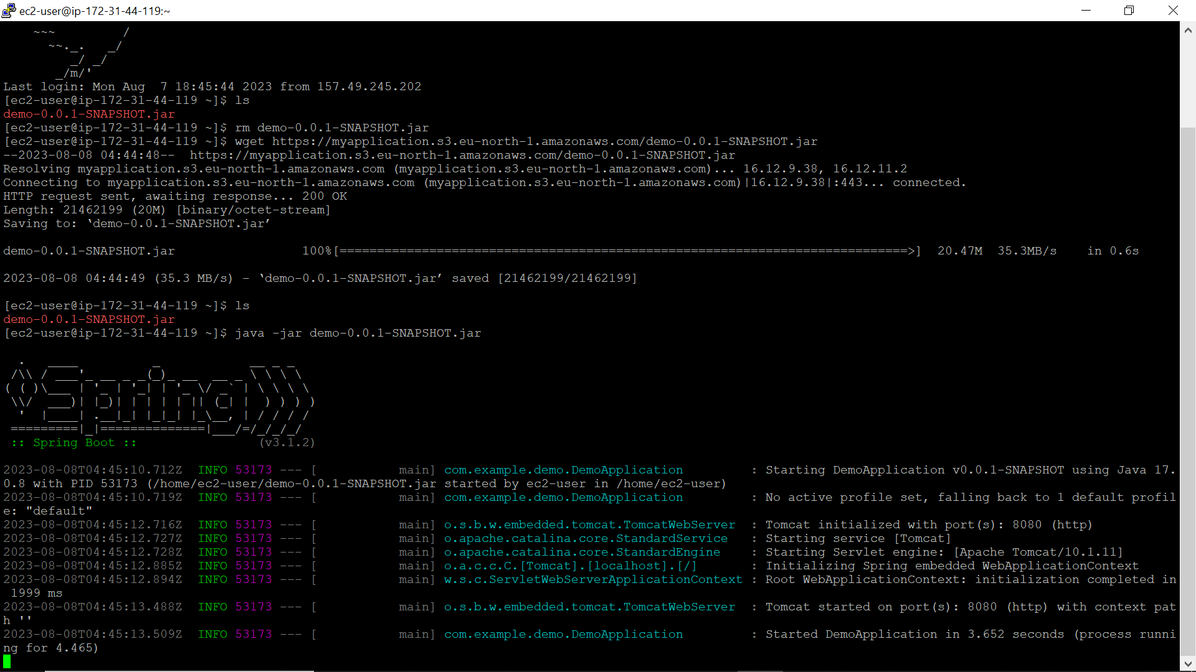

Fig 1.9

Now the application runs in the url <http://16.170.245.61:8080>

1. Run the React typescript application.

Goto S3 bucket and locate userpage1 bucket

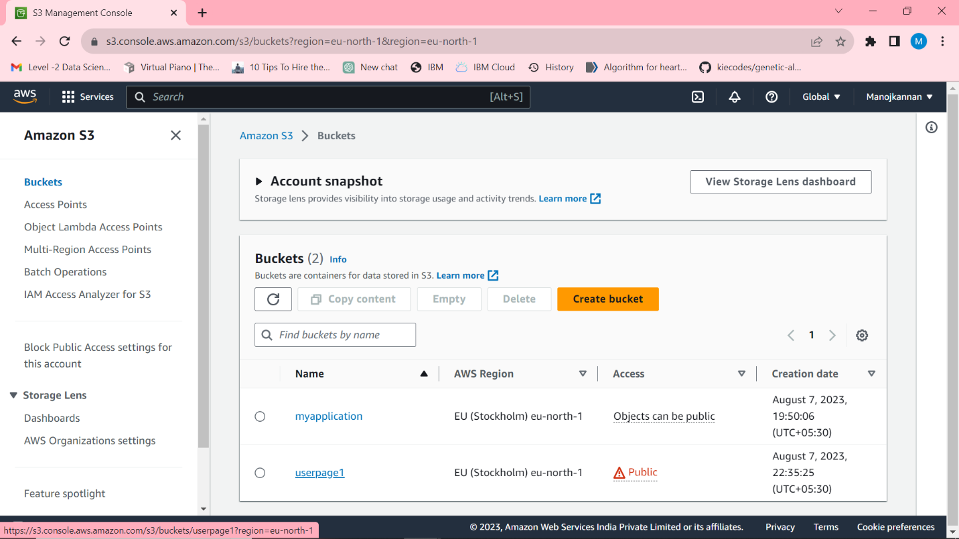

Fig 1.10

I have uploaded all files from build folder generated by react typescript application in local.

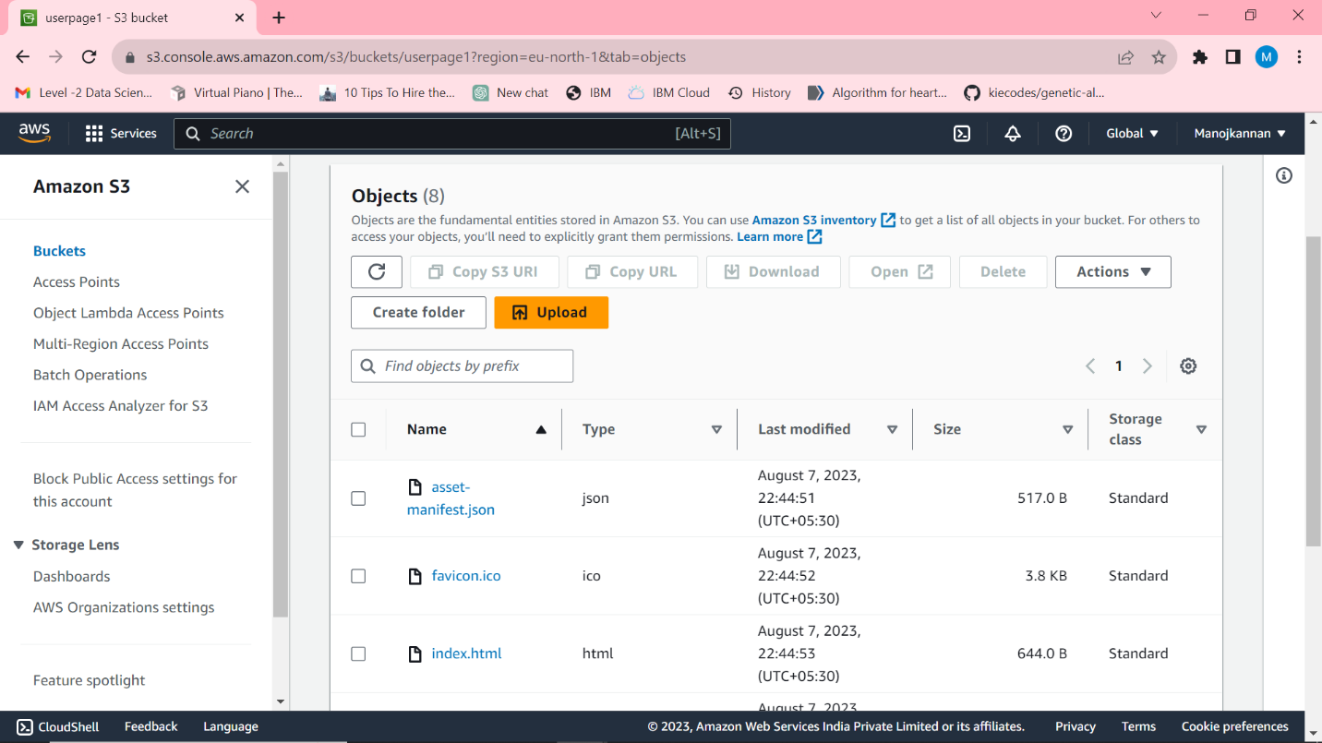

Fig 1.11

Goto properties in above,

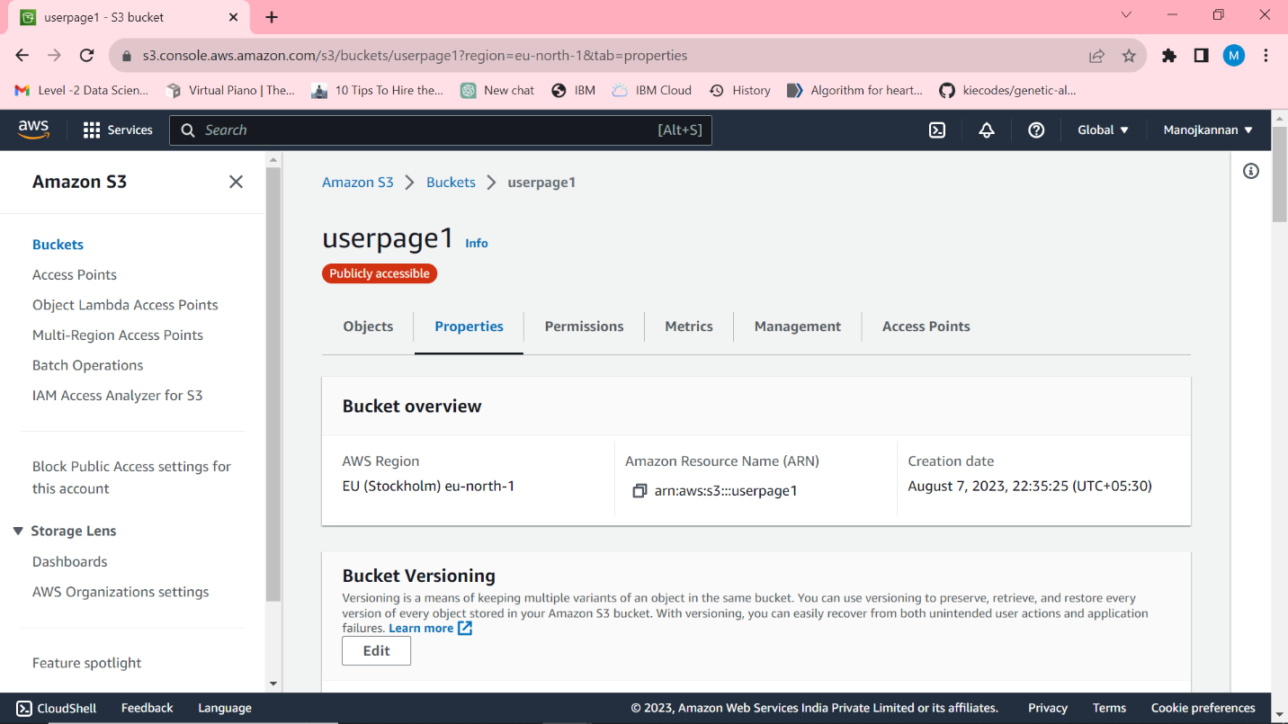

Fig 1.12

Bucket policy should be generated as below to allow the access and generate url for the application.

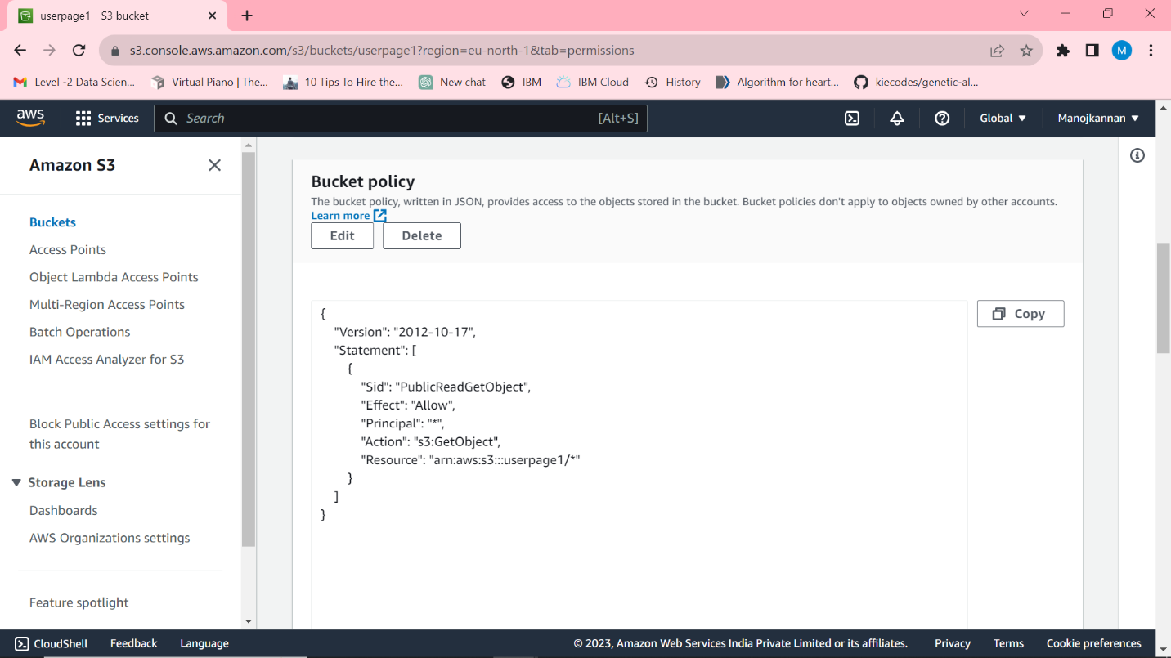

Fig 1.13

Copy the url in static website hosting below and navigate to the url.

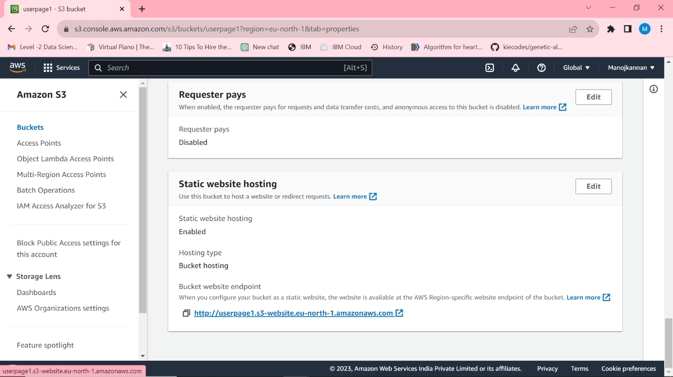

Fig 1.14

Application will run as below in the specified url,

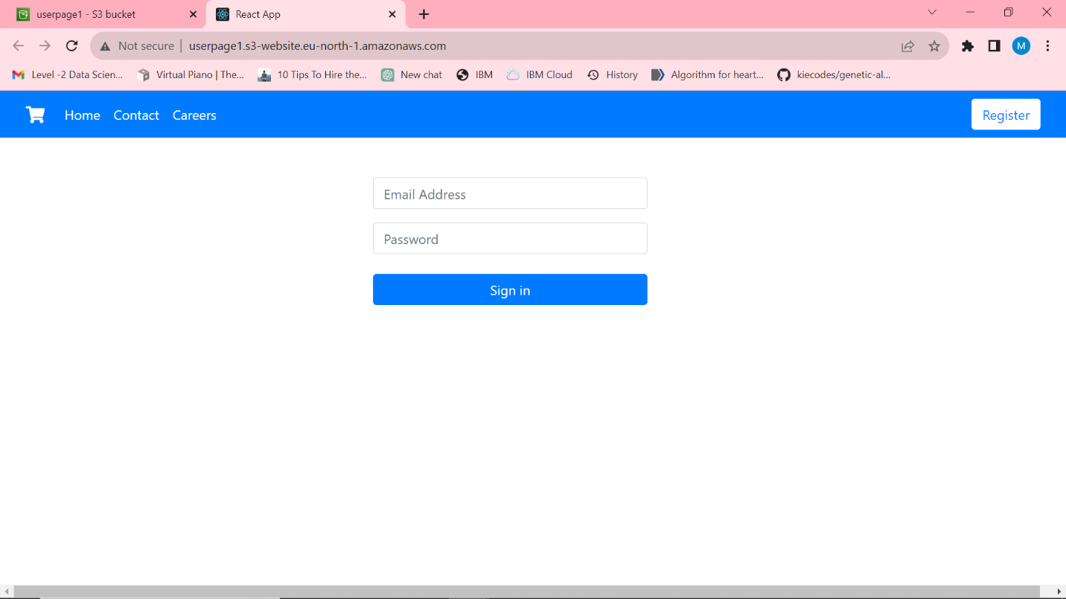

Fig 1.15

1. Working Process

First Step is to Register the user details,

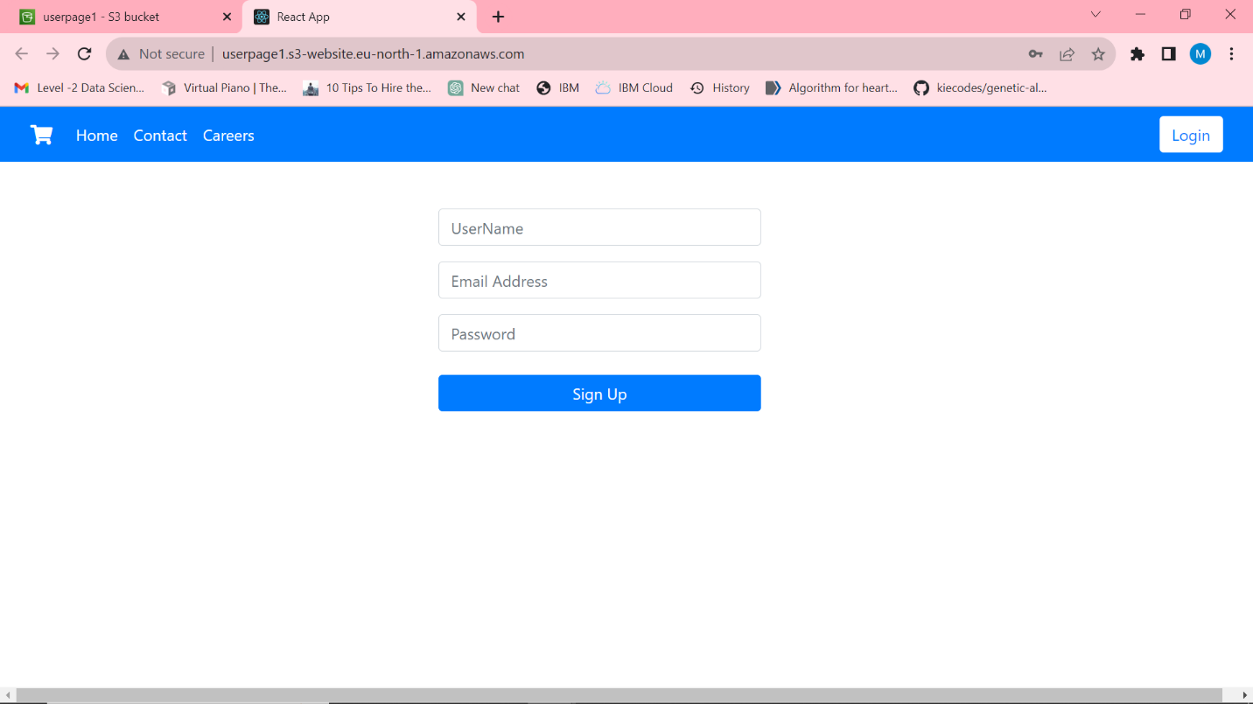

Fig 1.16

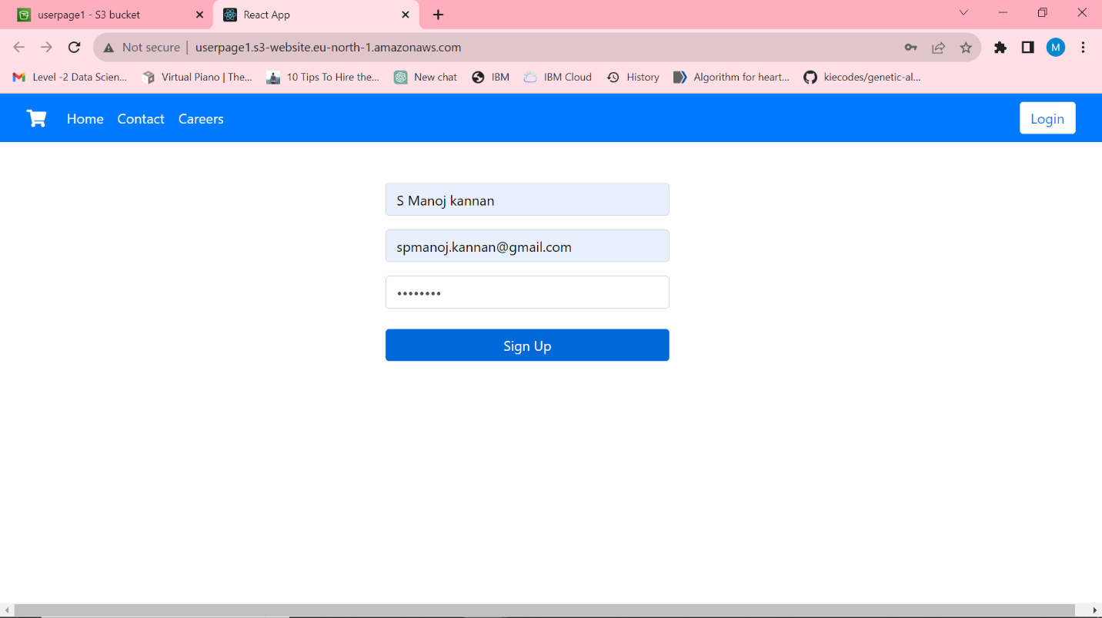

Fig 1.17

As we can see data has been successfully added to the database.

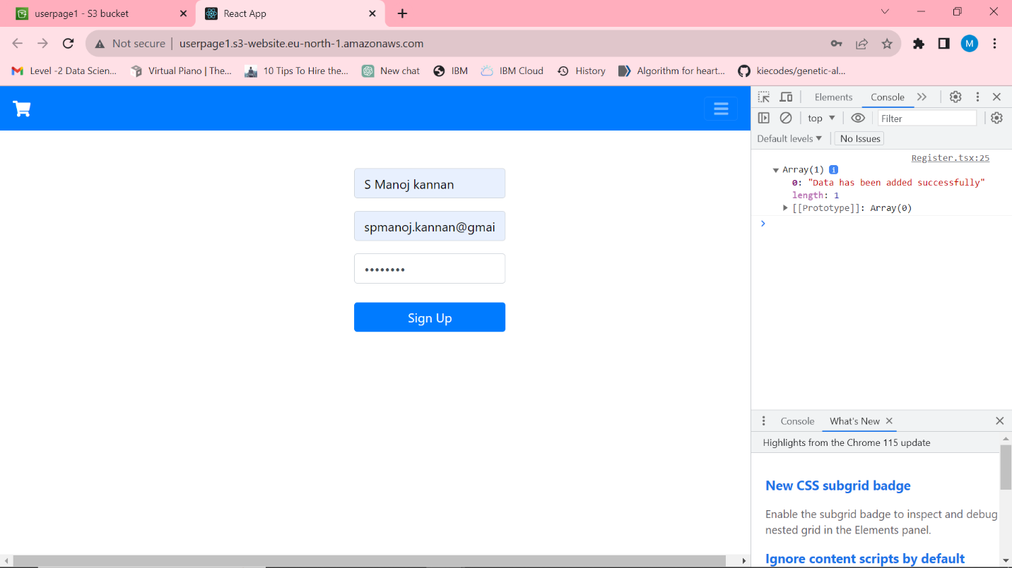

Fig 1.18

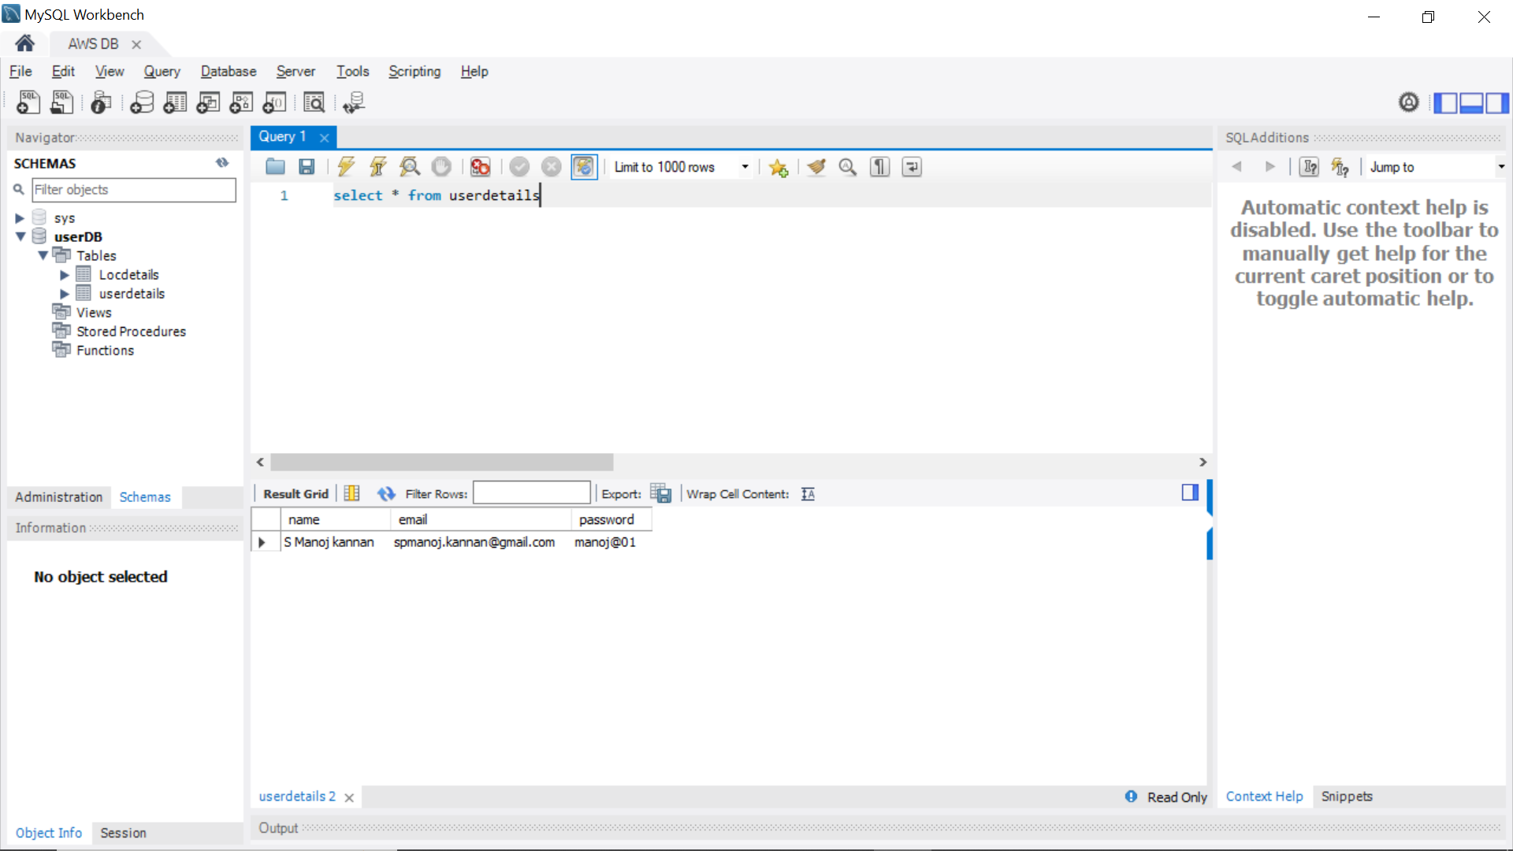

Fig 1.19

Now login through the credentials,

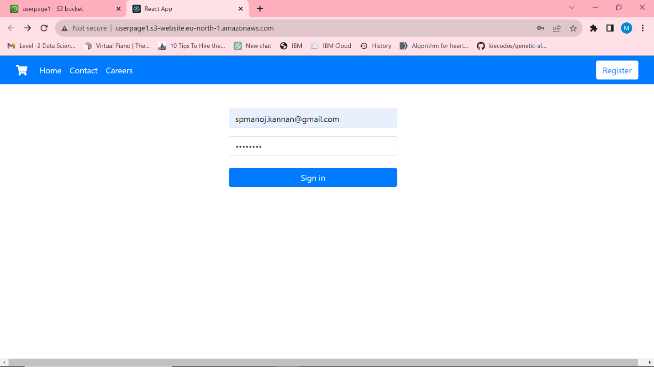

Fig 1.20

If successful, it navigates to dashboard which display as follows,

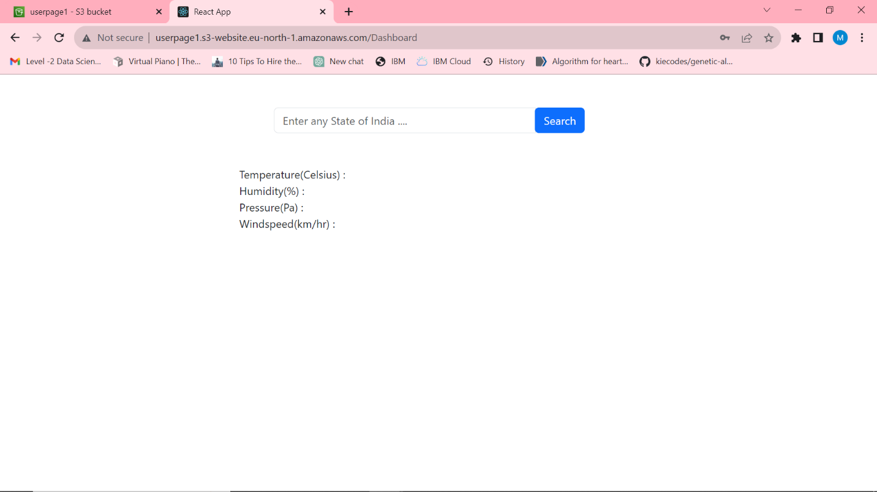

Fig 1.21

Now, enter any state of India to get the weather details,

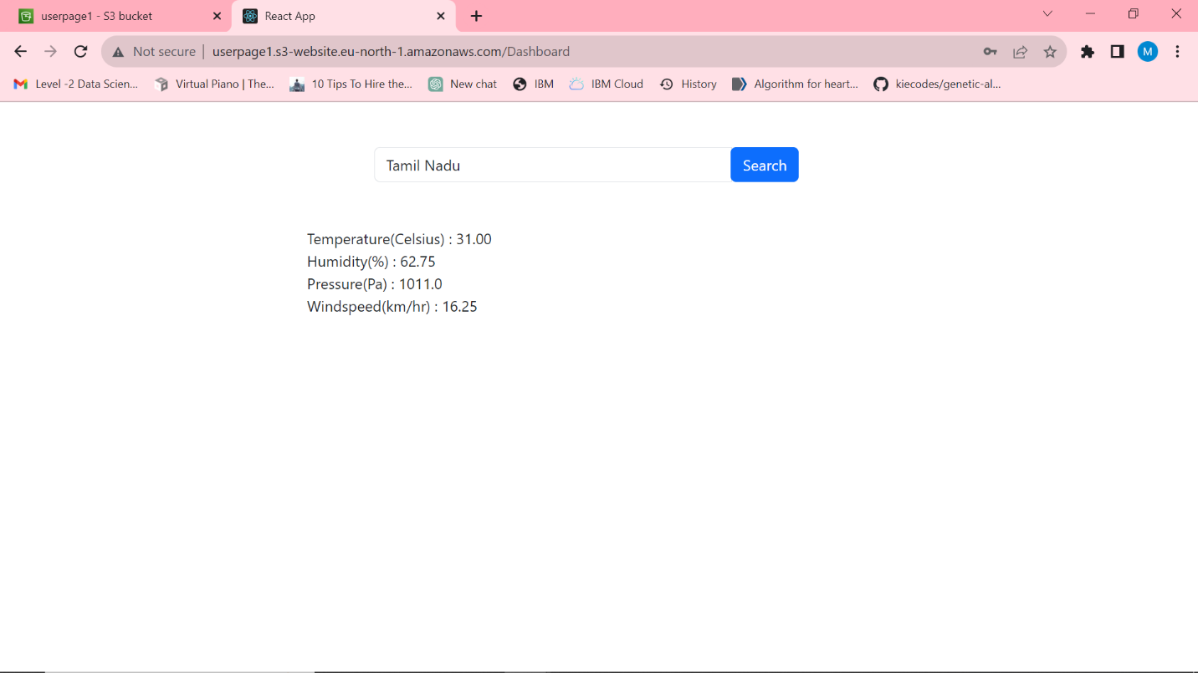

Fig 1.22

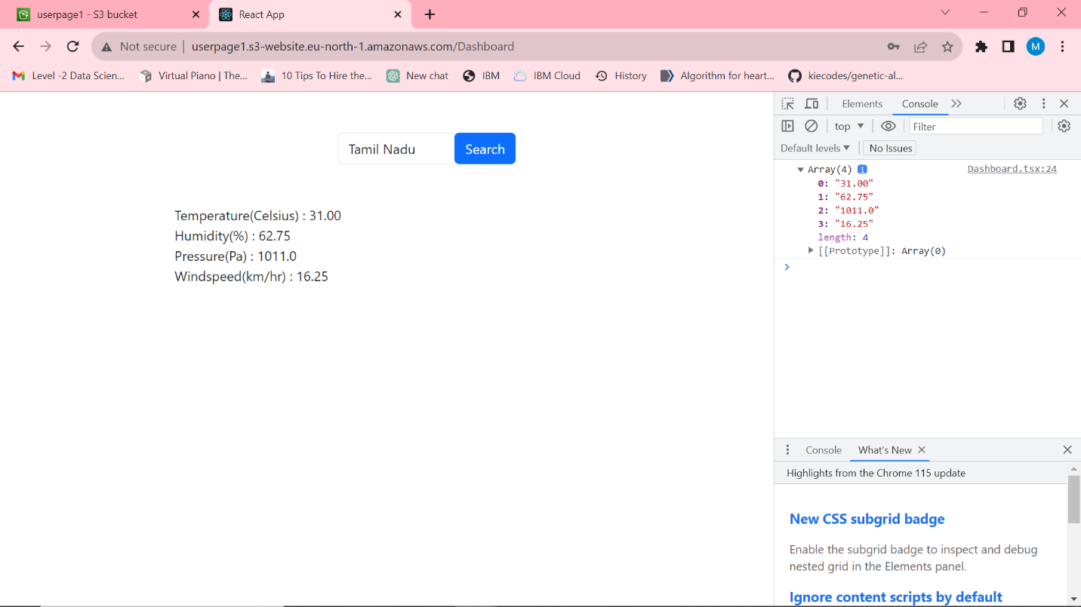

Fig 1.23

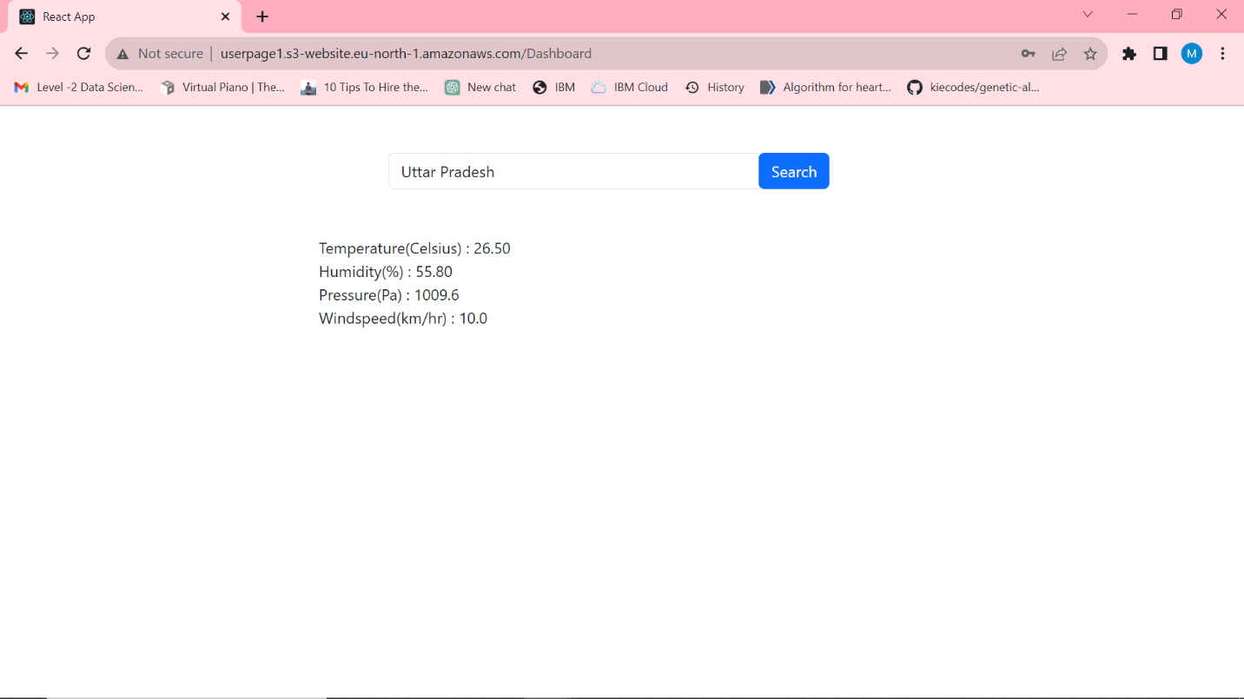

Fig 1.24

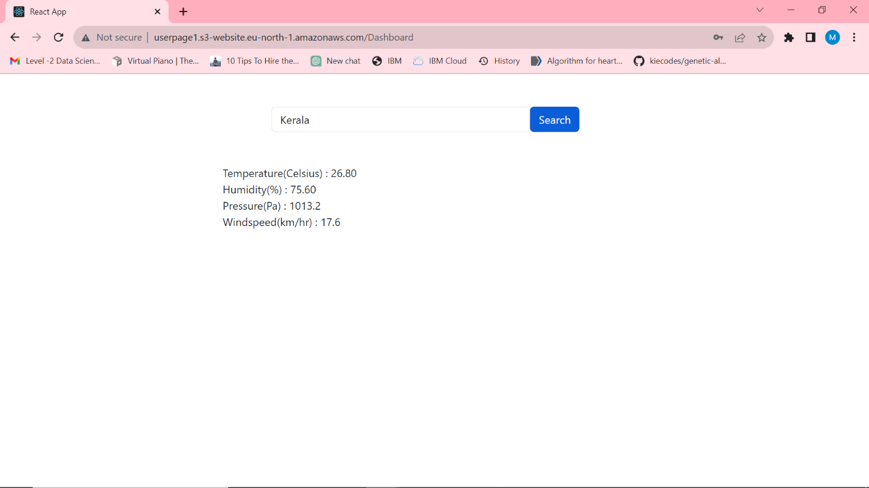

Fig 1.25